PROJECT REPORT

Student Burnout & Productivity Intelligence System

Table of Contents
Student Burnout & Productivity Intelligence System 1
Abstract 3
1. Introduction 4
2. Problem Statement 4
3. Objectives 4
4. System Designs and Methodology 5
4.1 System Architecture 5
4.2 Data Flow Diagram 5
4.3 ER Diagram 6
5. Methodology 7
5.1 Data Generation 7
5.2 Data Cleaning 7
5.3 Feature Engineering 7
5.4 Burnout Scoring Model 8
5.5 Classification System 8
5.6 Decision Support Layer 8
5.7 Database Design 9
5.8 Visualization 9
6. Implementation 9
6.1 Simulation Logic 9
6.2 Data Preprocessing 9
6.3 Feature Engineering & Mathematical Modeling 10
6.4 Decision Support System 10
7. Results and Dashboard Analysis 11
8. Conclusion 12
9. Future Work 12
10. Tools and Technologies 12
Appendix 13
Data Cleaning Implementation 13
Burnout Risk Calculation 13
Trigger Identification and Action Recommendation 13
Database Schema Definition 14

Abstract
This project presents a Student Burnout & Productivity Intelligence System designed to analyze behavioral and academic patterns to estimate burnout risk and productivity levels. The system integrates data generation, preprocessing, feature engineering, scoring models, and visualization to create an end-to-end analytics pipeline.
A synthetic time-series dataset is generated to simulate realistic student behavior, including sleep patterns, workload, stress levels, and academic pressure. The data is cleaned and transformed, followed by the creation of engineered features such as workload index, recovery balance, and distraction ratio.
A weighted burnout risk model is developed to quantify student burnout, along with a productivity scoring model. Students are classified into multiple risk levels using both primary and detailed classification systems.
The system is further enhanced with a decision-support layer, which identifies the primary contributing factor to burnout and suggests targeted interventions for at-risk students. The final output is visualized through an interactive Power BI dashboard.

1. Introduction
Student burnout is a growing concern in academic institutions, impacting both mental health and academic performance. Traditional monitoring methods rely on static indicators and lack the ability to capture behavioral trends over time.
This project aims to develop a data-driven system that:
- analyzes student behavioral patterns
- quantifies burnout risk
- evaluates productivity
- enables early intervention through actionable insights
The system combines data analytics, feature engineering, and visualization techniques to transform raw data into meaningful intelligence.

2. Problem Statement
Currently, most educational institutions do not have a structured system to monitor student burnout using behavioral and academic indicators. Student wellbeing is typically assessed through manual observation, feedback forms, or periodic counseling sessions, which lack real-time insight and scalability.

Existing approaches suffer from:

- lack of continuous monitoring
- absence of integrated behavioral and academic data
- inability to detect early-stage burnout
- no automated intervention mechanism

This project proposes a data-driven system that continuously analyzes student behavior, computes burnout risk, and provides actionable recommendations for early intervention.

3. Objectives
The main objectives of this project are:
- To simulate realistic student behavioral and academic data
- To preprocess and clean real-world-like noisy data
- To engineer meaningful features from raw inputs
- To design a burnout risk scoring model
- To classify students into risk categories
- To build an interactive dashboard for analysis
- To provide actionable recommendations for at-risk students

4. System Designs and Methodology

4.1 System Architecture
The system follows a decoupled architecture:
- Python acts as the Data Engine responsible for data generation, preprocessing, feature engineering, and scoring.
- MySQL acts as the Data Warehouse, storing structured data across normalized tables.
- Power BI serves as the Intelligence Layer, enabling visualization and user interaction.
The data flows from Python to MySQL through ETL processes, and from MySQL to Power BI for analysis.

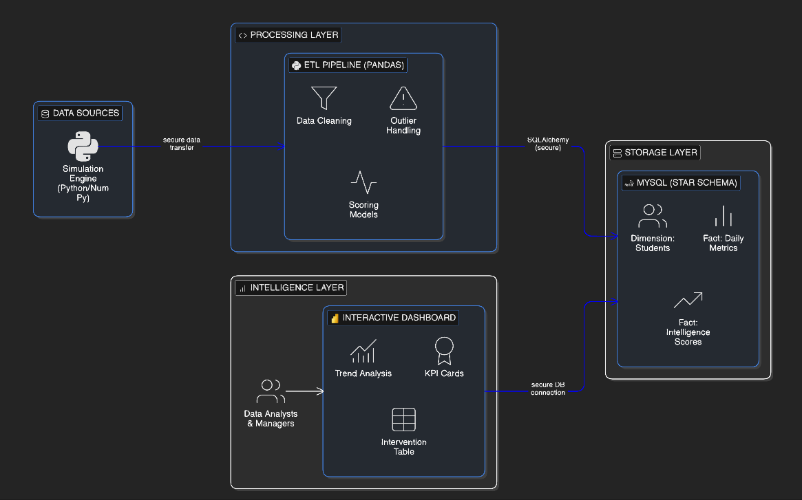

4.2 Data Flow Diagram
The system processes data through the following pipeline:
Raw Data → Cleaning → Feature Engineering → Scoring → Database Storage → Visualization
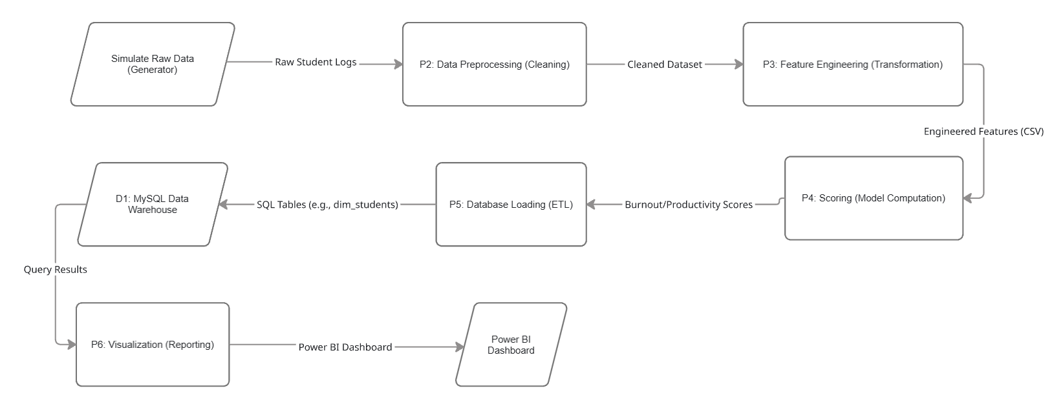

4.3 ER Diagram
The processed data is stored in a relational database using:
- dim_students
- fact_daily_metrics
- fact_academic_load
- fact_intelligence_scores
This ensures scalability and efficient querying.
CREATE TABLE dim_students (
student_id INT PRIMARY KEY,
department VARCHAR(50),
year_of_study INT,
residence_type VARCHAR(20)
);

-- Example of a Fact Table linking back
CREATE TABLE fact_intelligence_scores (
record_id INT AUTO_INCREMENT PRIMARY KEY,
student_id INT,
burnout_risk_score FLOAT,
FOREIGN KEY (student_id) REFERENCES dim_students(student_id)
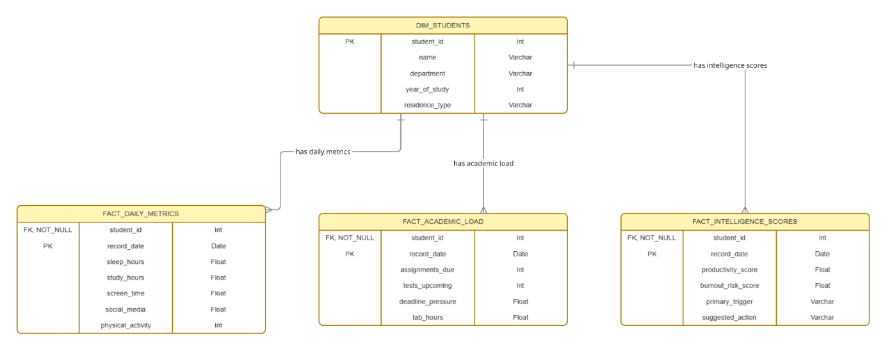
);

5. Methodology

5.1 Data Generation

A synthetic dataset is created to simulate realistic student behavior.

- 120 students
- 90 days
- 10,000+ records

Each record represents:

- one student
- one day of activity

This approach allows modeling of time-series behavior and controlled feature relationships.

5.2 Data Cleaning

The dataset includes realistic imperfections such as:

- missing values
- inconsistent formats
- duplicates
- outliers

Cleaning steps include:

- standardizing date formats
- handling missing values using imputation
- removing duplicates
- capping extreme values
- converting data types

5.3 Feature Engineering

Key features derived include:

- Sleep Deficit
- Workload Index
- Distraction Ratio
- Recovery Balance
- Deadline Pressure Score
- Productivity Score
- Burnout Risk Score

These features transform raw data into meaningful analytical variables.

5.4 Burnout Scoring Model
Burnout risk is calculated using a weighted combination of normalized features.
- Positive contributors: stress, fatigue, workload, sleep deficit
- Negative contributors: recovery balance, mood
The final score is scaled between 0 and 100.

5.5 Classification System
Two levels of classification are used:

Primary Classification

- Low
- Moderate
- High

Detailed Classification

- Very Low
- Low
- Moderate
- Elevated
- High
- Critical
The Elevated category helps identify students at risk before severe burnout.

5.6 Decision Support Layer
To enhance usability, the system includes a decision-support component.

- Identifies the primary trigger of burnout
- Suggests targeted interventions

Example:

- Sleep deficit → Sleep recovery
- Deadline pressure → Planning support

To avoid alert fatigue, recommendations are generated only for:

- Elevated
- High
- Critical

5.7 Database Design

The processed data is stored in a relational database using:

- dim_students
- fact_daily_metrics
- fact_academic_load
- fact_intelligence_scores

This ensures scalability and efficient querying.

5.8 Visualization

The system is visualized using Power BI with:

- KPI metrics
- Burnout distribution charts
- Department analysis
- Workload vs productivity scatter plot
- At-risk student intervention table
- Interactive filters (slicers)

6. Implementation

6.1 Simulation Logic
Since real-world datasets combining behavioral, academic, and psychological factors are not readily available, a synthetic dataset was generated.
The dataset simulates realistic student behavior over time, ensuring:

- correlation between workload and stress
- inverse relation between recovery and burnout
- time-series variation across days

This allows testing the system against behavioral logic rather than static data.

6.2 Data Preprocessing
The dataset contained several inconsistencies that required preprocessing.
Examples:
Issue | Example | Fix
Mixed formats | "7/10", "High" | Converted to numeric scale
Missing values | NULL entries | Mean/median imputation
Duplicates | Same student-date | Removed
Outliers | Extreme values | Capped
All fields were converted into consistent numeric formats for analysis.

6.3 Feature Engineering & Mathematical Modeling
Feature Table
Feature | Description | Formula
Sleep Deficit | Lack of sleep | 8 - sleep_hours
Workload Index | Academic pressure | Weighted sum
Distraction Ratio | Social media usage | social_media / screen_time
Recovery Balance | Recovery strength | weighted rest factors

Scaling
Different features exist in different units. For example, physical activity is measured in minutes, while assignments are counts.
To ensure fair combination, all features were scaled using Min-Max Scaling:
Scaled Value = (X - Min) / (Max - Min)
This converts all values into a common 0–100 range.

Burnout Formula

Burnout Risk Score =
0.17 × Sleep Deficit
+ 0.20 × Stress
+ 0.16 × Fatigue
+ 0.16 × Workload
+ 0.10 × Deadline Pressure
+ 0.08 × Distraction
- 0.08 × Recovery
- 0.05 × Mood

6.4 Decision Support System
To enhance usability, the system includes a decision-support layer.
For each at-risk student, the system:

- identifies the primary contributing factor (trigger)
- generates a recommended action
Example:

- Sleep Deficit → Recommend sleep recovery
- Deadline Pressure → Recommend planning support

To avoid alert fatigue, recommendations are generated only for:

- Elevated
- High
- Critical

This ensures focus on high-priority cases.

7. Results and Dashboard Analysis
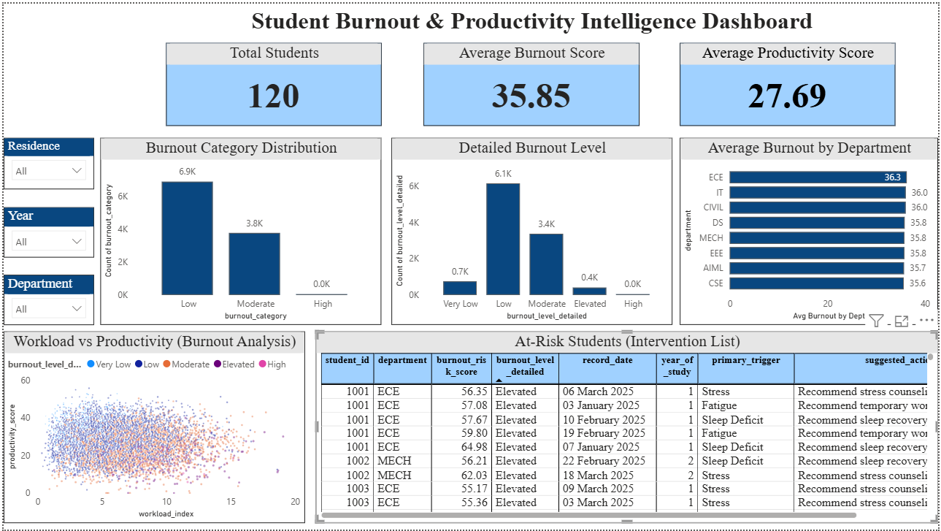
The dashboard provides both high-level insights and actionable intelligence.

Key observations:

  - Majority of students fall in Low and Moderate categories
  - Elevated category helps early detection
  - Burnout correlates more with behavioral patterns than department
  - Productivity shows diminishing returns at high workload

The scatter plot shows the relationship between workload and productivity.

It highlights:

  - increasing productivity with moderate workload
  - decreasing productivity at high workload due to burnout
  - presence of outliers representing resilient students

The At-Risk Student table identifies:

  - high-risk students
  - primary cause of burnout
  - suggested intervention

This transforms the system into an actionable decision tool.

The analysis reveals:

- Majority of students fall in Low and Moderate burnout categories
- Elevated category acts as an early warning group
- Burnout is more influenced by behavioral factors than department
- Productivity does not increase linearly with workload
- High workload may reduce productivity at extreme levels
The intervention table enables identification of students requiring attention.

8. Conclusion
This project successfully demonstrates how student behavioral and academic data can be transformed into an interpretable burnout intelligence system.
By integrating feature engineering, scoring models, classification, and decision support, the system provides both analytical insights and actionable recommendations.
The solution highlights the importance of early detection and targeted intervention in managing student wellbeing.

9. Future Work
- trend analysis over time
- predictive modeling using machine learning
- personalized intervention recommendations
- integration with real-world datasets
- institutional deployment

10. Tools and Technologies
- Python (Pandas, NumPy)
- MySQL
- SQLAlchemy
- Power BI
- Git & GitHub

Appendix

Data Cleaning Implementation
The following code snippet demonstrates how inconsistent data formats were handled during preprocessing.
For example, the stress level column contained values such as "7/10", "High", and numeric values. These were standardized into a consistent numeric format.

def clean_stress(value):
if isinstance(value, str):
if "/" in value:
return float(value.split("/")[0])
elif value.lower() == "high":
return 8
elif value.lower() == "medium":
return 5
elif value.lower() == "low":
return 2
return float(value)

Burnout Risk Calculation
The burnout risk score is computed using a weighted combination of normalized features. The following code snippet shows the implementation of the scoring logic.

df["burnout_risk_score"] = (
0.17 * df["sleep_deficit_scaled"]
+ 0.20 * df["stress_scaled"]
+ 0.16 * df["fatigue_scaled"]
+ 0.16 * df["workload_index_scaled"]
+ 0.10 * df["deadline_pressure_scaled"]
+ 0.08 * df["distraction_ratio_scaled"]
- 0.08 * df["recovery_balance_scaled"]
- 0.05 * df["mood_scaled"]
)

Trigger Identification and Action Recommendation
The system identifies the primary contributing factor for burnout and generates a suggested action for intervention. This enhances the system from a descriptive model to a decision-support system.

trigger_columns = [
"sleep_deficit_scaled",
"stress_scaled",
"fatigue_scaled",
"workload_index_scaled",
"deadline_pressure_scaled",
"distraction_ratio_scaled"
]
df["primary_trigger"] = df[trigger_columns].idxmax(axis=1)

Database Schema Definition
The following SQL schema defines the structure of the database used in the system.

CREATE TABLE fact_intelligence_scores (
student_id INT,
record_date DATE,
burnout_risk_score FLOAT,
burnout_level_detailed VARCHAR(20),
primary_trigger VARCHAR(50),
suggested_action VARCHAR(255)
);

